**Terraform Assignment – 1**

● Create an EC2 service in the default subnet in the ohio region.

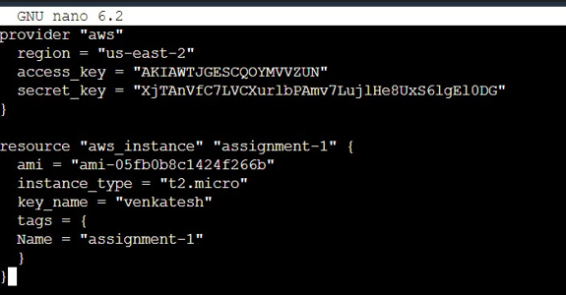

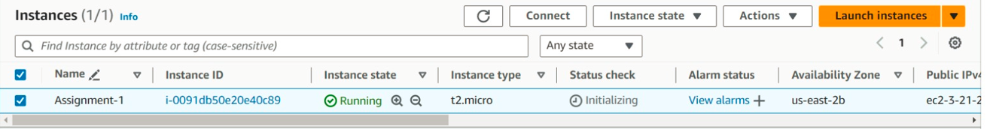

**Terraform Assignment – 2**

● Destroy the previous deployment

● Create a new EC2 instance with an Elastic IP

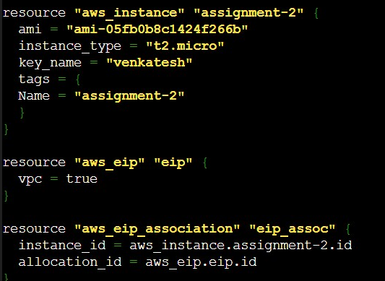

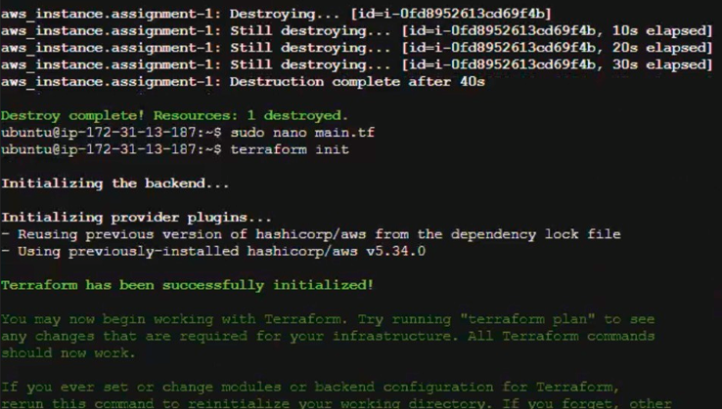

**Terraform Assignment – 3**

● Destroy the previous deployment

● Create 2 EC2 instances in Ohio and N.Virginia respectively

● Rename Ohio’s instance to ‘hello-ohio’ and Virginia’s instance to ‘hello-virginia’

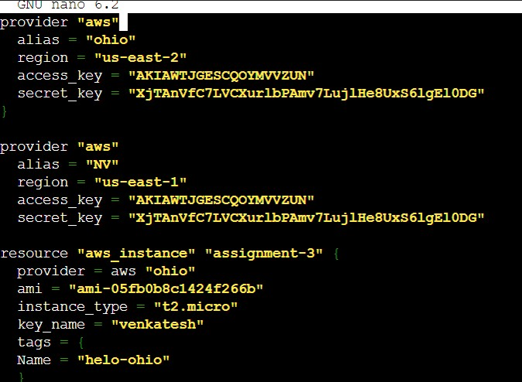

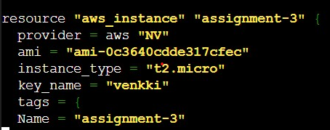

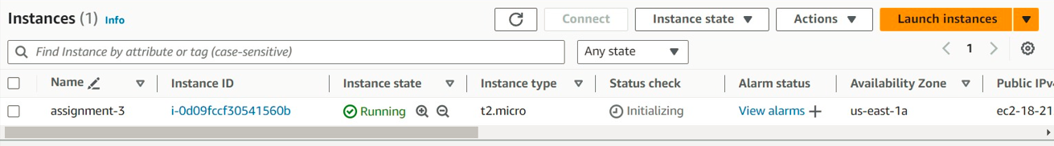

**Terraform Assignment – 4**

● Destroy the previous deployments

● Create a VPC with the required components using Terraform

● Deploy an EC2 instance inside the VPC

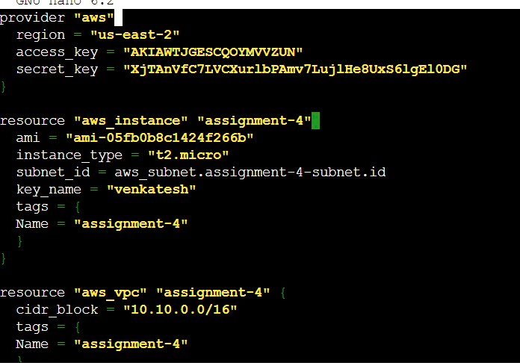

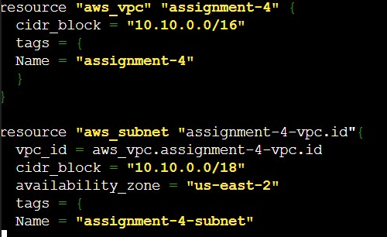

**Terraform Assignment – 5**

● Destroy the previous deployments

● Create a script to install apache2

● Run this script on a newly created EC2 instance

● Print the IP address of the instance in a file on the local, once deployed

